Project Planning Phase

**Project Planning Template (Product Backlog, Sprint Planning, Stories, Story Points)**

|  |  |
| --- | --- |
| DATE | 28 October 2022 |
| TEAM ID | PNT2022TMID50687 |
| PROJECT NAME | Fertilizer Recommendation System for Disease Prediction |
| MAXIMUM MARK | 8 Marks |

Product Backlog, Sprint Schedule, and Estimation (4 Marks)

|  |  |  |  |  |  |  |
| --- | --- | --- | --- | --- | --- | --- |
| **Sprint** | **Functional**  **Requirement (Epic)** | **User Story Number** | **User Story / Task** | **Story**  **Points (Total)** | **Priority** | **Team Members** |
| Sprint-1 | Model Creation and Training (Fruits) |  | Make a model which can group sick natural product plants from given pictures. I likewise need to test the model and send it on IBM Cloud | 8 | High | Shunmuga Priya,Pavithra,Packiya Felsiba,Gayathri . |
|  | Model Creation and Training (Vegetables) |  | Make a model which can order unhealthy vegetable plants from given pictures | 2 | High | Shunmuga Priya,Pavithra,Packiya Felsiba,Gayathri |

|  |  |  |  |  |  |  |
| --- | --- | --- | --- | --- | --- | --- |
| **Sprint** | **Functional Requirement**  **(Epic)** | **User Story Number** | **User Story / Task** | **Story Points**  **(Total)** | **Priority** | **Team Members** |
| Sprint-2 | Model Creation and Training (Vegetables) |  | Make a model which can characterize sick vegetable plants from given pictures and train on IBM Cloud | 6 | High | ShunmugaPriya,  Pavithra,Packiya Felsiba,Gayathri. |
|  | Registration | USN-1 | As a client, I can enroll by entering my email, secret key, and affirming my secret phrase or by means of OAuth Programming interface | 3 | Medium | ShunmugaPriya,  Pavithra,Packiya Felsiba,Gayathri. |
|  | Upload page | USN-2 | As a client, I will be diverted to a page where I can transfer my photos of yields | 4 | High | ShunmugaPriya,  Pavithra,Packiya Felsiba,Gayathri |
|  | Suggestion results | USN-3 | As a client, I can see the outcomes and afterward get the ideas given by the ML model | 4 | High | ShunmugaPriya,  Pavithra,Packiya Felsiba,Gayathri. |
|  | Base Flask App |  | A base Flagon web application should be made as a point of interaction for the ML model | 2 | High | ShunmugaPriya,  Pavithra,Packiya Felsiba,Gayathri |
| Sprint-3 | Login | USN-4 | As a client/administrator/retailer, I can sign into the application by entering email and secret phrase | 2 | High | ShunmugaPriya,  Pavithra,Packiya Felsiba,Gayathri |
|  | User Dashboard | USN-5 | As a client, I can see the past outcomes and history | 3 | Medium | ShunmugaPriya,  Pavithra,Packiya Felsiba,Gayathri |
|  | Integration |  | Incorporate Carafe, CNN model with Cloudant DB | 5 | Medium | ShunmugaPriya,  Pavithra,Packiya Felsiba,Gayathri. |
|  | Containerization |  | Containerize Cup application utilizing Docker | 2 | Low | ShunmugaPriya,  Pavithra,Packiya Felsiba,Gayathri |

|  |  |  |  |  |  |  |
| --- | --- | --- | --- | --- | --- | --- |
|  |  |  |  |  |  |  |
| Sprint-4 | Dashboard (Admin) | USN-6 | As an administrator, I can see other client subtleties and transfers for different purposes | 2 | Medium | ShunmugaPriya,  Pavithra,Packiya Felsiba,Gayathri. |
|  | Dashboard (Shopkeeper) | USN-7 | As a retailer, I can enter manure items and afterward update the subtleties if any | 2 | Low | ShunmugaPriya,  Pavithra,Packiya Felsiba,Gayathri. |
|  | Containerization |  | Make and send Rudder graphs utilizing Docker Picture made previously | 2 | Low | ShunmugaPriya,  Pavithra,Packiya Felsiba,Gayathri. |

Project Tracker, Velocity & Burndown Chart: (4 Marks)

|  |  |  |  |  |  |  |
| --- | --- | --- | --- | --- | --- | --- |
| **Sprint** | **Total Story Points** | **Duration** | **Sprint Start Date** | **Sprint End Date (Planned)** | **Story Points Completed (as on**  **Planned End Date)** | **Sprint Release Date (Actual)** |
| Sprint-1 | 10 | 6 Days | 24 Oct 2022 | 29 Oct 2022 | 10 | 30 Oct 2022 |
| Sprint-2 | 15 | 6 Days | 31 Oct 2022 | 05 Nov 2022 | 15 | 06 Nov 2022 |
| Sprint-3 | 15 | 6 Days | 07 Nov 2022 | 12 Nov 2022 | 15 | 13 Nov 2022 |
| Sprint-4 | 12 | 6 Days | 14 Nov 2022 | 19 Nov 2022 | 10 | 20 Nov 2022 |

***NOTE: Burndown charts, Velocity to be updated dynamically after end of sprints***

Roadmap:

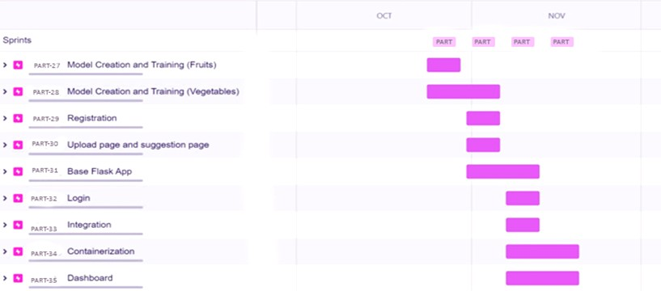

Screenshots:

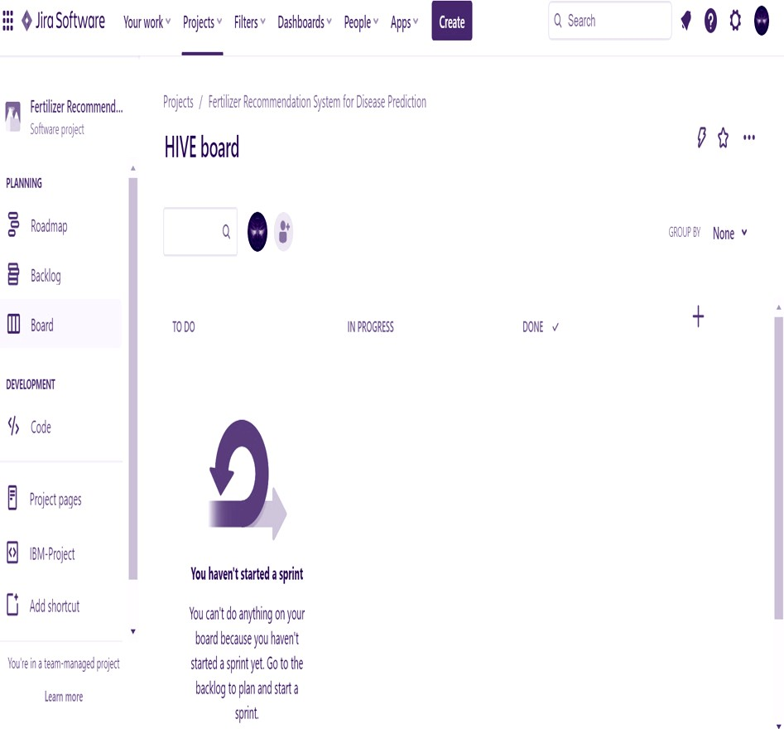

PART Board

